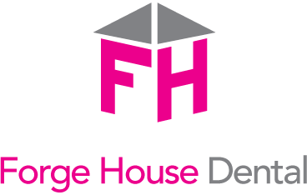
Forge House
High Street
Staplehurst
Tonbridge
Kent TN12 0AH

01580 892 509
forgehouse.dentalpractice@nhs.net
info@forgehousedental.co.uk
www.forgehousedental.co.uk

PERIODONTAL REFERRALS

Mrs ENNATA ADELEYE DDS, MSc (Perio), FDS RCS (Eng)
Practice Limited to Periodontology

REFERRING PRACTITIONER’S DETAILS

Name: …………………………………………………………………………………………………….……… Date: ………………..…………..
Practice Address: ………………………………………………………………………………………………………………………...…………..
…………………………………………………………………………………………………………………………………………………………….
…………………………………………………………....................Practice Contact Number: …………………………………………………

PATIENT’S DETAILS
Patient’s Name: ……………………………………………………………………………………………….. D.O.B: ……………………….……
Patient’s Address: ……………………………………………………………………………………………………………………………………
……………………………………………………………………………………………………………………………………….……………………
Patient’s Contact Numbers: Home: …………………………….. Mobile: …………………….……….Work: ………………………………

REFERRAL FOR:

Periodontal Assessment and Treatment

Periodontal Assessment and Treatment Plan Only

Surgical Crown Lengthening
Teeth/tooth ………………………………………………

Medical History: ……………………………………………………………………………………………………………………………..
……………………..………………………………………………………………………… Smoker Yes No
Radiographs* enclosed (up to 1 year old): Yes No E-mailed Yes No

Patient’s consent obtained for referral? Yes No
More referral forms needed Yes No

*Radiographs and the form can be e-mailed to: forgehouse.dentalpractice@nhs.net or info@forgehousedental.co.uk

